

# *PPC Marketing Millions Presents:* Quick Start Set Up Guide PPC Marketing MillionsQuick Account Set Up: Fool Proof Quick Start Guide

When it comes to setting up your PPC account, there are a handful of steps that are required in order to have everything up and running successfully. We will cover each aspect of this throughout this report so that you can get it all set up quickly and easily.

PPC marketing involves:

* Creating your PPC marketplace account
* Compile a list of relevant keywords
* Tweak your account settings for optimum results
* Create killer campaigns that suck in traffic
* Effectively funnel traffic to money pages

To begin, head on over to: <http://adwords.google.com/select> to create your account now.

Click on the "Start Now" link to begin the quick and easy registration process. It will only take roughly ten minutes to set up your account before you will be ready to customize it and create your campaigns.

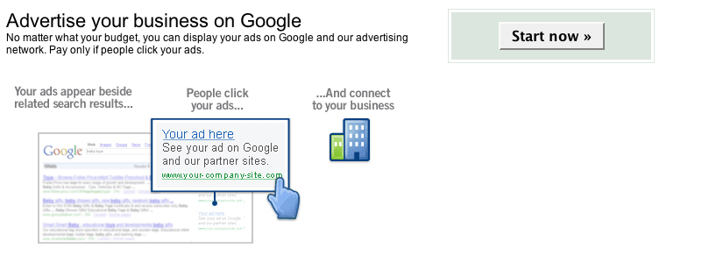

The next page will offer you the ability to create either a Starter Account or a Standard Edition.

Within this report, we will use the Standard Advertising option, so that our primary focus is establishing exposure within the entire Google Adwords network, rather than specific websites in our niche market.

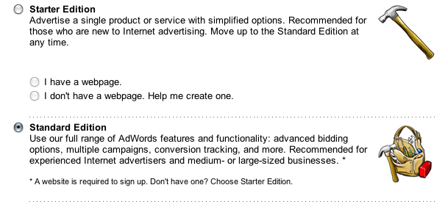

Select Standard Edition and click “Continue”.

In order to continue, you will need a Google account. This can include a gmail account, Orkut or even iGoogle.

If you do not currently have a Google based account, select “I do not use these other services” to be given additional options, such as using your domain based email account or perhaps the one provided to you by your Internet Service Provider.

You will now choose the currency that you would like to use with your Google Adwords account. Select your local currency, and click Continue.

You will now be directed to a processing page while Google sets up your new Adwords account.

Upon completion, you will reach an account registration thank you page that indicates you must confirm your request by checking your email and clicking on the validation link contained in your introductory welcome email.

Once you have verified your request, you will be able to log into your Google Adwords account and set up your campaigns.

The first time you log into Adwords you will be given the opportunity to update information relating to your target audience, as well as whether you plan to advertise to specific groups by location or language.

Personally, my focus is on English speaking customers as that is my primary language and the language in which my website is created in.

I also choose to include a wide variety of countries including Canada, United States, Australia, United Kingdom, Japan and so on.

Setting these options will depend on what your focus and overall scope is in terms of target audience.

Are you interested in only advertising to those within your own country?

Perhaps your product or service is only available in specific countries, or maybe you wish to showcase your advertisements in front of as many people as possible.

You will need to determine this within your Adwords settings to ensure that your advertisements are only triggered when a user enters in your keywords from an IP address within your permitted country list.

The flexibility offered through language and location targeting allows advertisers to develop content tailored to specific groups, nationalities and locations.

This is an exceptional benefit of the Adwords system if you are planning to cater to specific languages such as French or Spanish, or you are interested in only having your advertisements appear to residents of certain countries.

In order to completely activate your account, you will have to enter in your billing information. You can do this at a later date, once you have set up your campaigns and are ready to launch them.

You will also be required to pay a one-time activation fee. Once you have activated your account and set up your campaigns, you will begin to see your advertisements appear within minutes.

When you create campaigns, you will design each one so that it’s focused on specific groups. In order to do that, you will enter in keyword phrases associated to the markets that you advertise to.

Another great benefit of using Google is that they place no minimum order restrictions on accounts. This means that you can start advertising on Google without having to invest a lot of money.

In addition, you can easily edit your budget at any time should you wish to start off small and increase it as you become more experienced using the system.

Remember, you are not charged each time your ad appears within Googles Sponsored Listings, and instead, are only charged each time someone clicks on your.

As a Google Adwords marketer, we will be creating campaigns that advertise specific websites. With Google Adwords, you can create as many campaigns and advertisements as you wish, with no limits.

This makes it easy to promote dozens of websites or even dozens of pages all on the same site (which can be used to split test your copy and track performance easily).

Within each campaign that we create, we target it towards specific keywords that are entered into Google's search engine by potential customers. These keywords are grouped together and assigned to each campaign that we select.

For example, if I were involved in two different markets, such as Weight Loss and Relationships, I would set up two different campaigns using keywords and advertisements focusing on those two specific markets.

These keywords need to be direct and highly relevant in order to yield the best results, which is why keyword research is such a critical aspect of successful PPC marketing.

You never want to combine your advertisements, because after you have a dozen or so in place, it would become difficult to manage, so keep it all organized as you go along.

Which brings me to another quick point; when it comes to PPC marketing, you **NEED** to stay on top of your campaigns.

You want to always know how your advertisements are performing, whether they require tweaking, or if they can simply be improved in some way (and believe me, most can, especially when you are just starting out).

Never forget this, it can be the difference between sinking hundreds of dollars into a campaign unnecessarily, or in saving a fortune by making a few simple adjustments.

The best way to make it easier when managing your account is to label your campaigns based on titles you will easily recognize.

That way, you can easily identify your different campaigns the moment you log into your account, rather than wasting time sorting through them trying to determine what is what.

You would be surprised how many people who are new to using Google Adwords title their campaigns in such a way that it’s nearly impossible to know which group is targeting what product (Campaign 1, Campaign 2, etc), so be sure that you take a few minutes to set this up correctly, so it’s easier to manage later on.

After creating your campaigns, you will need to assign keywords to each one.

These are called “Ad Groups” and they consist of keyword phrases that are relevant to your products or the websites you are promoting.

Your account also offers features extended options including reports that provide detailed information regarding your account, including overall performance.

These reports and data will become invaluable to you once your accounts are live, so take some time to familiarize yourself with the general layout of your Adwords account, so you can refer to these resources later on.

Analytics is also an added feature available to all Adwords marketers, and revealed detailed information on your overall conversion rates, website visitors, IP addresses and much more.

This information can help you better target your customer base and ensure that those clicking your ads are genuinely interested in what you have to offer.

If you find that the majority of your website visitors fail to stay on your site for any length of time, and your sales aren't improving even though your traffic is, these reports will help you identify potential problems with your campaigns so that you can fix them.  
  
You are now ready to set up your first campaign and begin to generate massive, highly targeted traffic to your website!  
  
Download the complete ***PPC Marketing Millions*** guide, where I reveal the insider trade secrets to dominating the PPC marketing, sucking in unlimited traffic while paying LESS per click than your competitors while maintaining a higher position!  
  
The guide includes everything you need to know.

Visit **WWW.YOURDOMAINHERE.COM** and grab your copy.